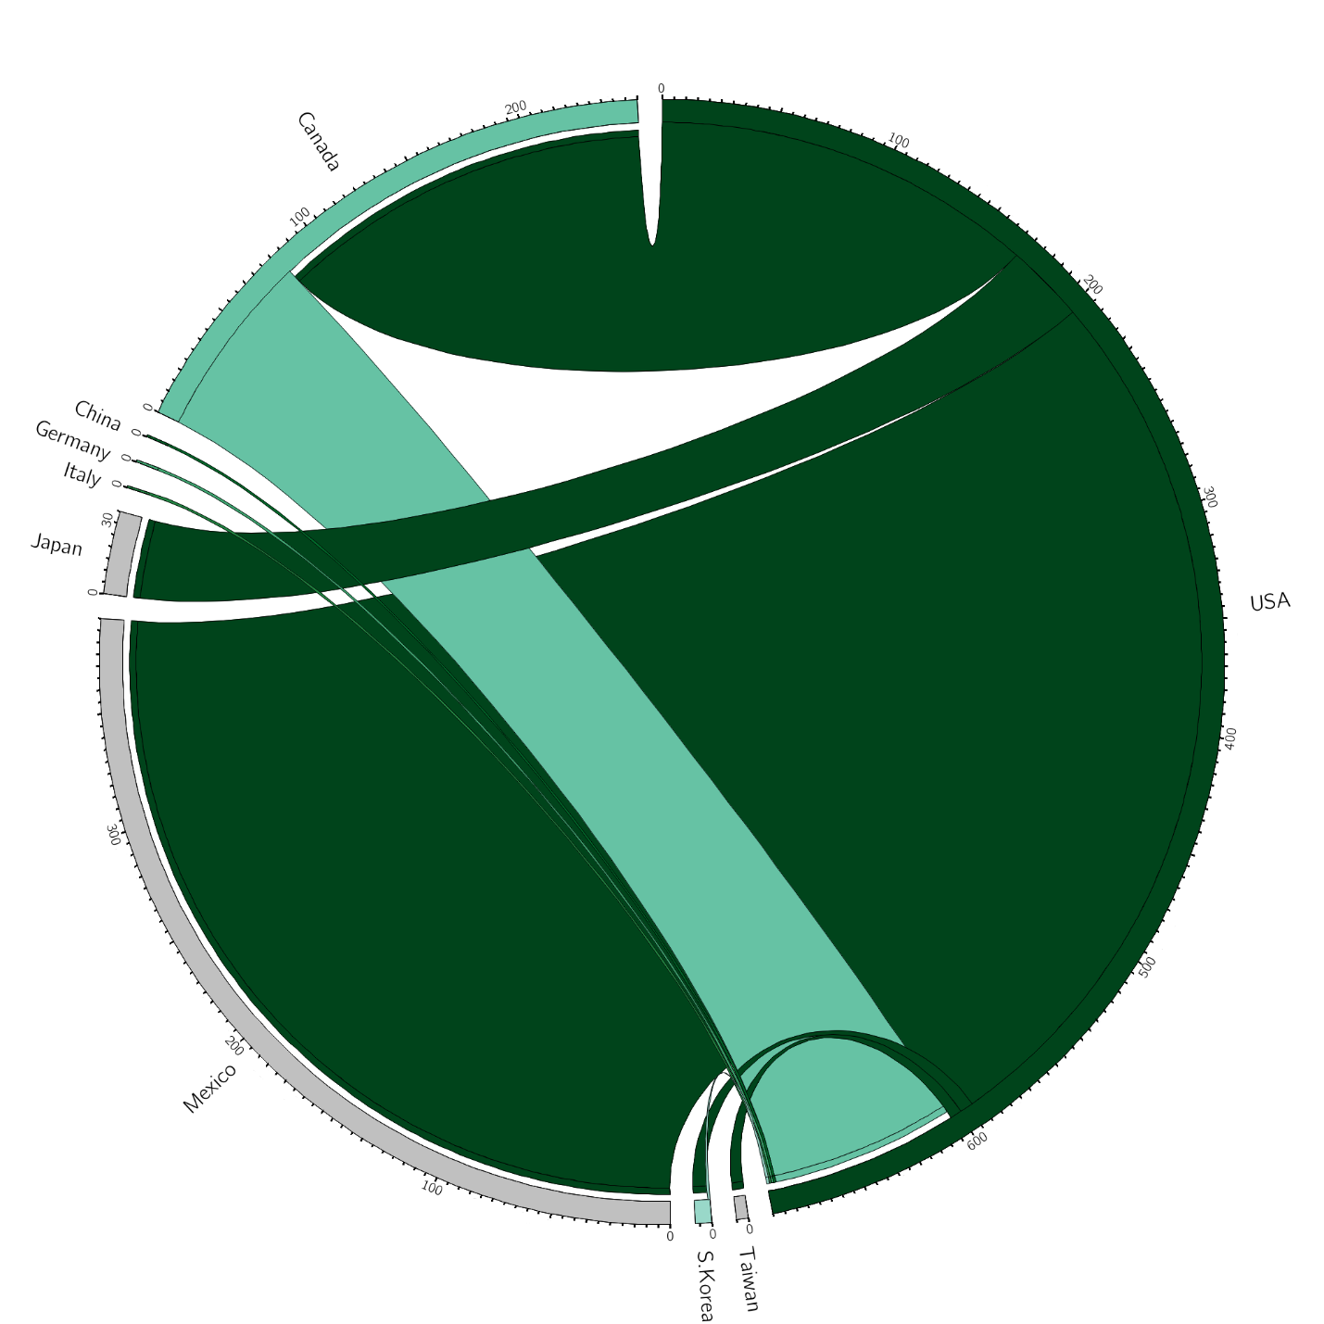
Figure #. The chord diagram visualizes the flow of Barley (1,000 metric tons) to and from the United States. The top five import and export destinations are represented by the various segments within the circle. The direction of the flow is denoted by the color of the origin country, as well as a gap between the flow and the destination county. Flows are depicted to scale. However, as flow widths are nonlinearly adapted to the curvature of the circle, quantities are based off of the beginning/end of the flow segment, with larger bands representing a larger trade of Barley. Mexico is the largest importer of U.S. Barley, while Canada is the largest exporter to the United States.
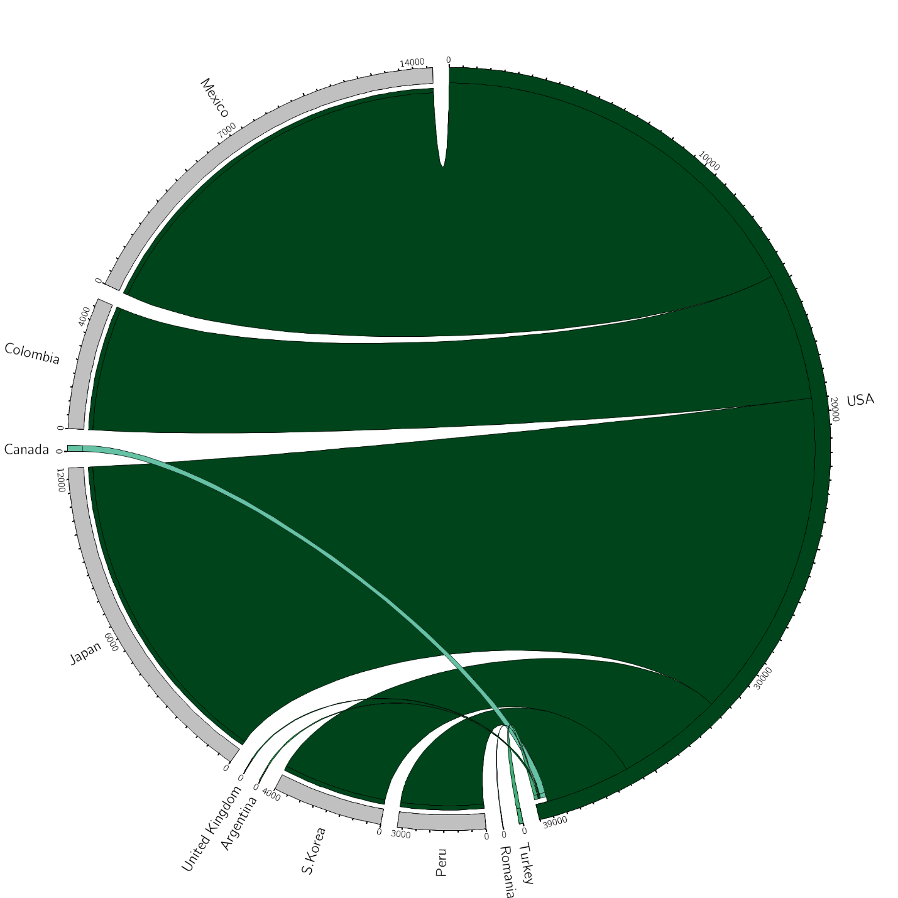
Figure #. The chord diagram visualizes the flow of Corn (1,000 metric tons) to and from the United States. The top five import and export destinations are represented by the various segments within the circle. The direction of the flow is denoted by the color of the origin country, as well as a gap between the flow and the destination county. Flows are depicted to scale. However, as flow widths are nonlinearly adapted to the curvature of the circle, quantities are based off of the beginning/end of the flow segment, with larger bands representing a larger trade of Corn. Mexico is the largest importer of U.S. Corn, while Canada is the largest exporter to the United States.

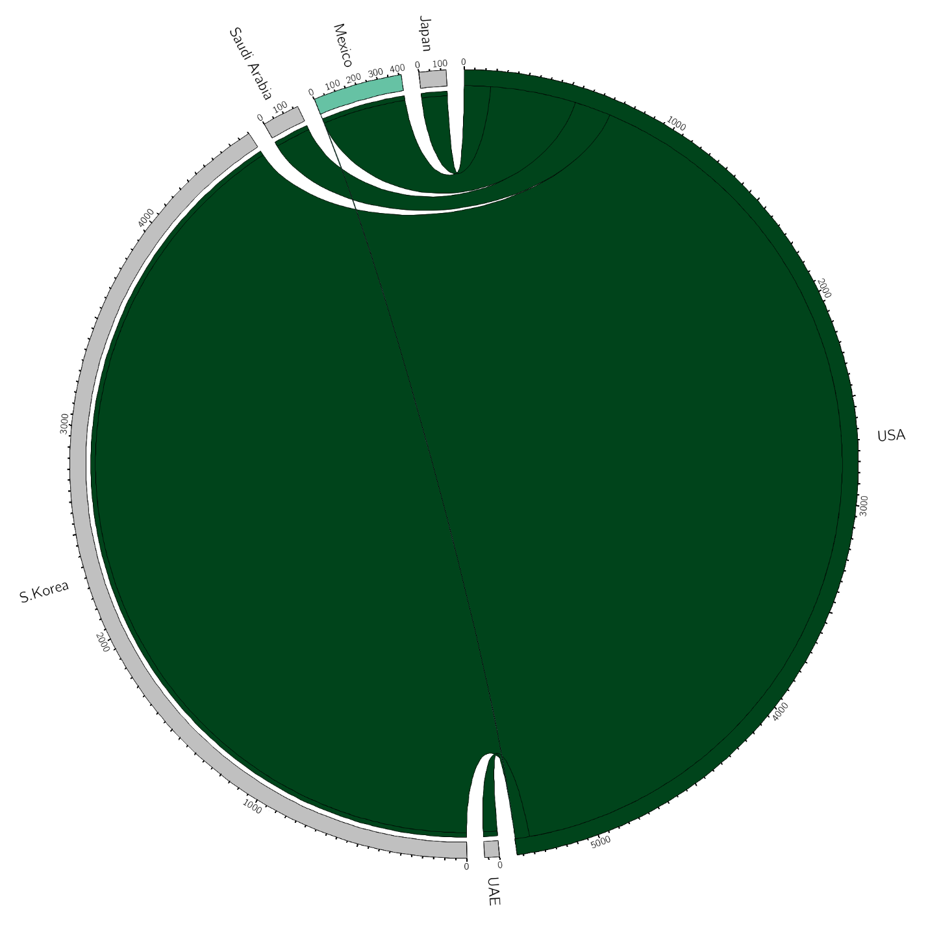
Figure #. The chord diagram visualizes the flow of Cottonseed (1,000 metric tons) to and from the United States. The top five import and export destinations are represented by the various segments within the circle. The direction of the flow is denoted by the color of the origin country, as well as a gap between the flow and the destination county. Flows are depicted to scale. However, as flow widths are nonlinearly adapted to the curvature of the circle, quantities are based off of the beginning/end of the flow segment, with larger bands representing a larger trade of Cottonseed. South Korea is the largest importer of U.S. Cottonseed, while Mexico is the only exporter to the United States.

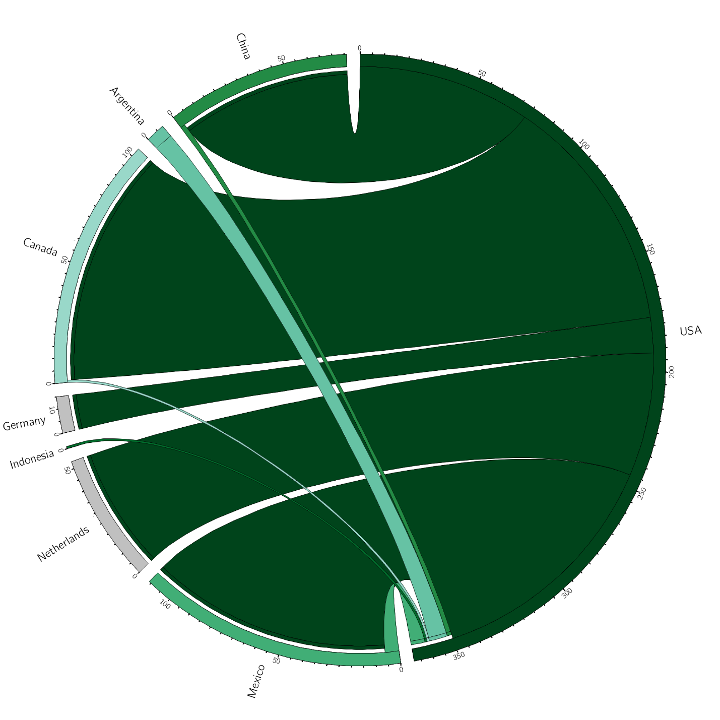
Figure #. The chord diagram visualized the flow of Peanuts (1,000 metric tons) to and from the United States. The top five import and export destinations are represented by the various segments within the circle. The direction of the flow is denoted by the color of the origin country, as well as a gap between the flow and the destination county. Flows are depicted to scale. However, as flow widths are nonlinearly adapted to the curvature of the circle, quantities are based off of the beginning/end of the flow segment, with larger bands representing a larger trade of Peanuts. Canada is the largest importer of U.S. Peanuts, while Argentina is the largest exporter to the United States.

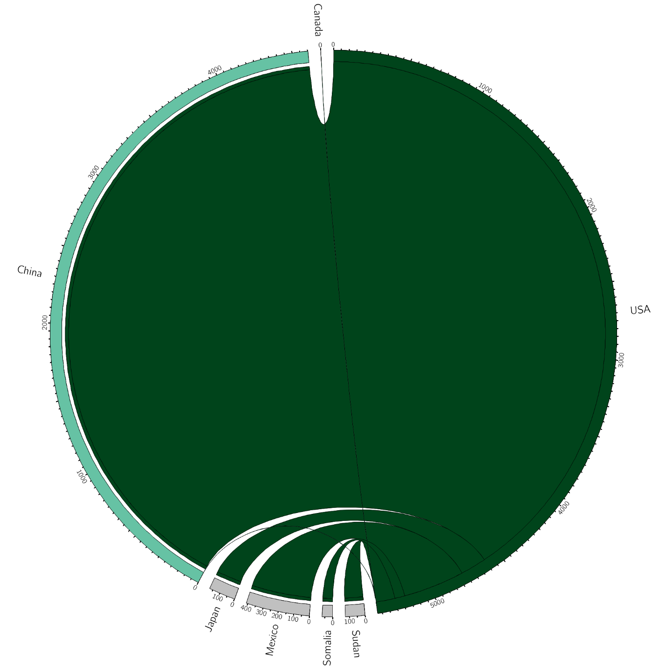
Figure #. The chord diagram visualizes the flow of Sorghum (1,000 metric tons) to and from the United States. The top five import and export destinations are represented by the various segments within the circle. The direction of the flow is denoted by the color of the origin country, as well as a gap between the flow and the destination county. Flows are depicted to scale. However, as flow widths are nonlinearly adapted to the curvature of the circle, quantities are based off of the beginning/end of the flow segment, with larger bands representing a larger trade of Sorghum. China is by far the largest importer of U.S. Sorghum, with more than 10x the second-largest importing country, Mexico. The U.S. imports a very small amount of Sorghum from China and Canada.

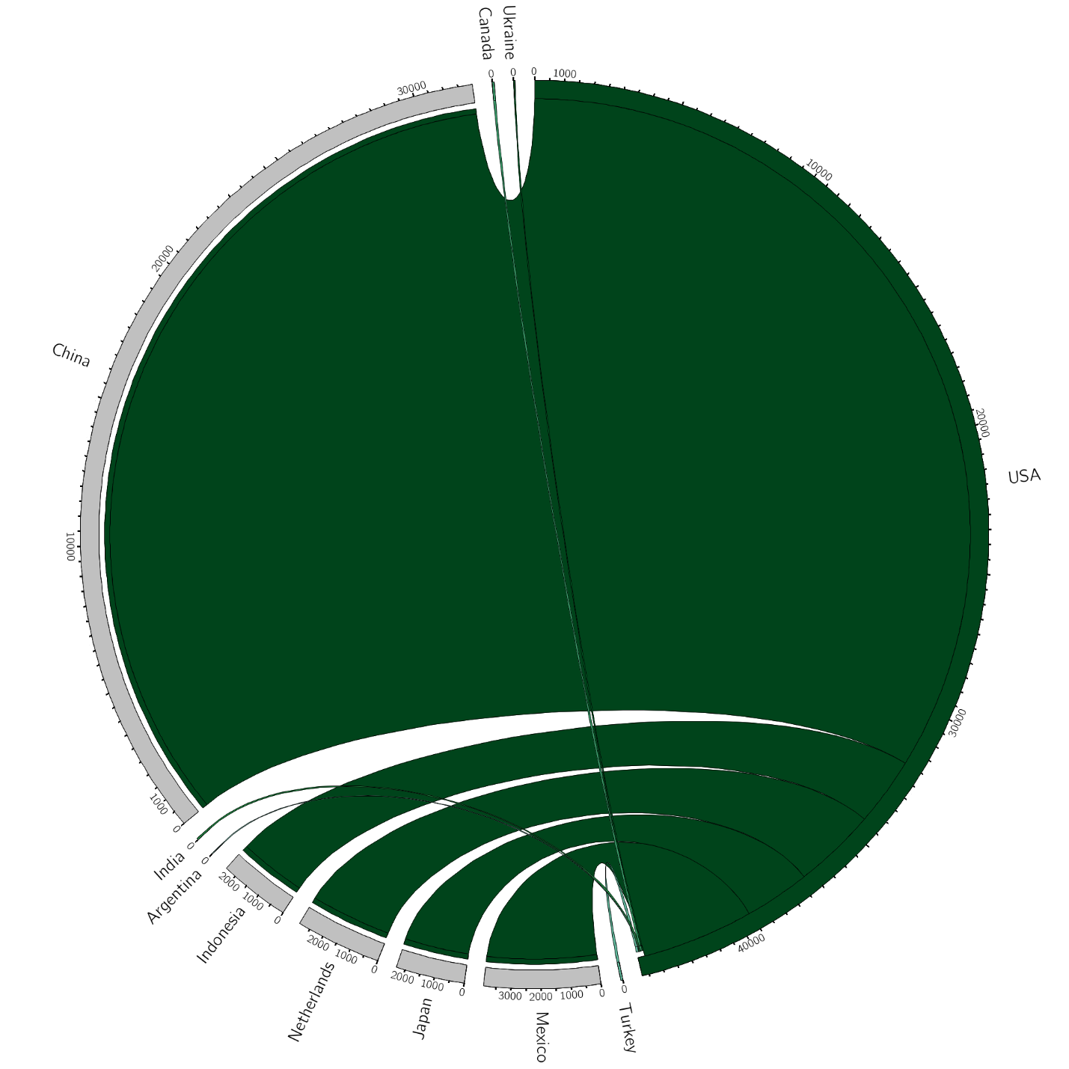
Figure #. The chord diagram visualizes the flow of Soybeans (1,000 metric tons) to and from the United States. The top five import and export destinations are represented by the various segments within the circle. The direction of the flow is denoted by the color of the origin country, as well as a gap between the flow and the destination county. Flows are depicted to scale. However, as flow widths are nonlinearly adapted to the curvature of the circle, quantities are based off of the beginning/end of the flow segment, with larger bands representing a larger trade of Soybeans. China is by far the largest importer of U.S. Soybeans, with more than 8x the second-largest importing country, Mexico. Turkey is the largest importer of Soybeans to the United States.
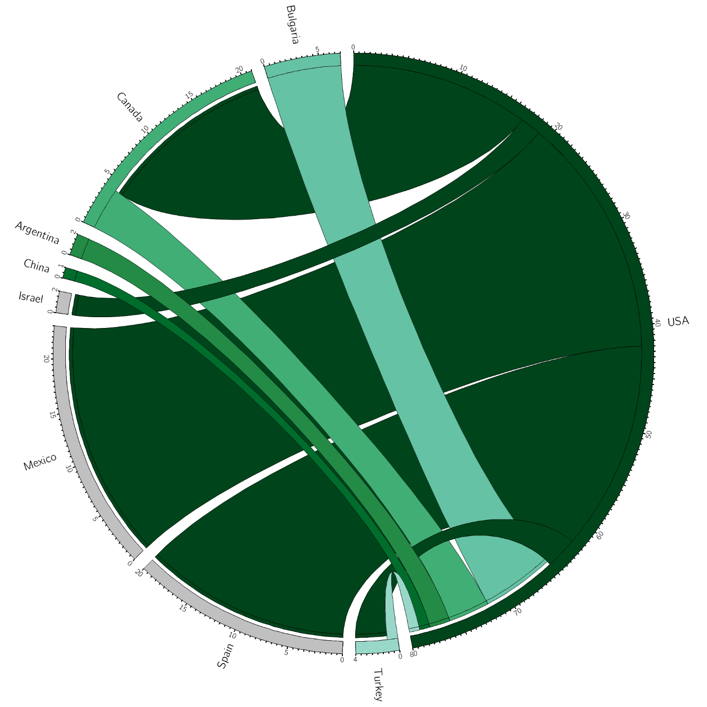
Figure #. The chord diagram visualizes the flow of Sunflowers (1,000 metric tons) to and from the United States. The top five import and export destinations are represented by the various segments within the circle. The direction of the flow is denoted by the color of the origin country, as well as a gap between the flow and the destination county. Flows are depicted to scale. However, as flow widths are nonlinearly adapted to the curvature of the circle, quantities are based off of the beginning/end of the flow segment, with larger bands representing a larger trade of Soybeans. Mexico is the largest importer of U.S. Sunflowers, while Bulgaria is the largest exporter to the United States.

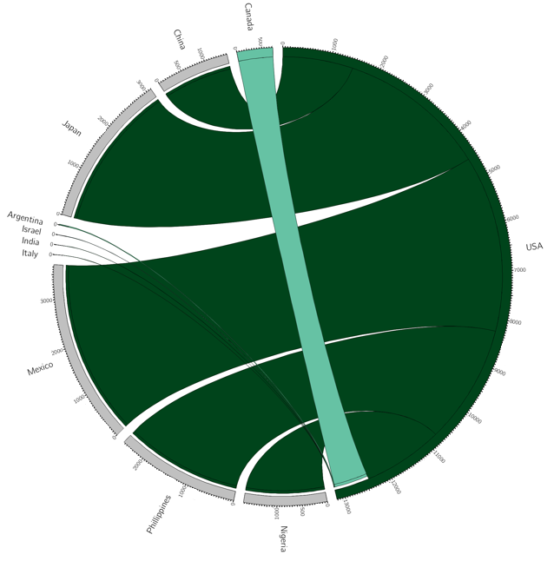
Figure #. The chord diagram visualizes the flow of Wheat (1,000 metric tons) to and from the United States. The top five import and export destinations are represented by the various segments within the circle. The direction of the flow is denoted by the color of the origin country, as well as a gap between the flow and the destination county. Flows are depicted to scale. However, as flow widths are nonlinearly adapted to the curvature of the circle, quantities are based off of the beginning/end of the flow segment, with larger bands representing a larger trade of Wheat. Mexico is the largest importer of U.S. Wheat, while Canada is the largest exporter to the United States.

